kubernetes task 08

1.Create and Test a Kubernetes Pod with an EmptyDir Volume
Create Pod YAML
# vi dir-pod.yml
apiVersion: v1
kind: Pod
metadata:
name: emptydir-pod
spec:
containers:
- name: app
image: busybox
command: ["sh", "-c", "echo Hello from emptyDir > /data/message.txt && sleep 3600"]
volumeMounts:
- name: cache-volume
mountPath: /data
volumes:
- name: cache-volume
emptyDir: {}

Deploy Pod
# kubectl apply -f dir-pod.yml

Verify Data
# kubectl exec -it emptydir-pod -- cat /data/message.txt

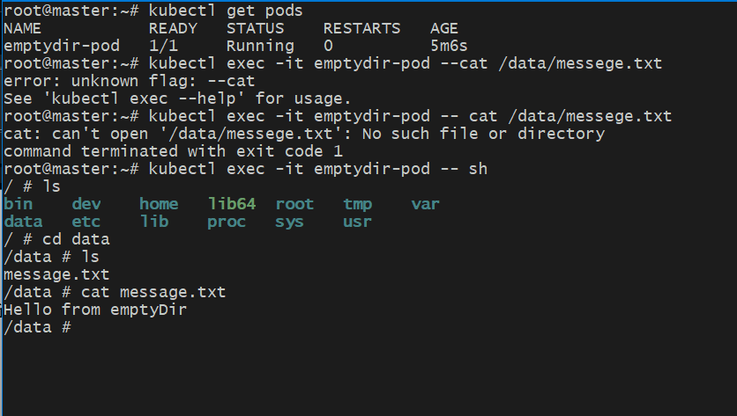
Test Ephemeral Nature
# kubectl delete pod emptydir-pod
deleted when the Pod is removed
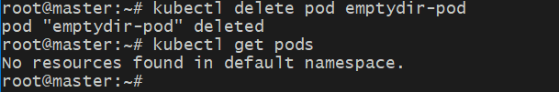

2. Configure a HostPath Volume in Kubernetes and Validate Data Persistence

Create HostPath Pod YAML
# vi hostpod.yml
apiVersion: v1
kind: Pod
metadata:
name: hostpath-pod
spec:
containers:
- name: app
image: busybox
command: ["sh", "-c", "echo HostPath Data > /host/data.txt && sleep 3600"]
volumeMounts:
- name: host-volume
mountPath: /host
volumes:
- name: host-volume
hostPath:
path: /tmp/k8s-data
type: DirectoryOrCreate
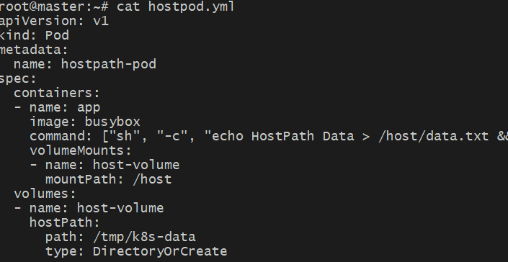
Deploy Pod
# kubectl apply -f hostpath-pod.yaml

Login to the pod
# kubectl exec -it hostpath-pod – sh

Go to dir
# cd host

Create random files

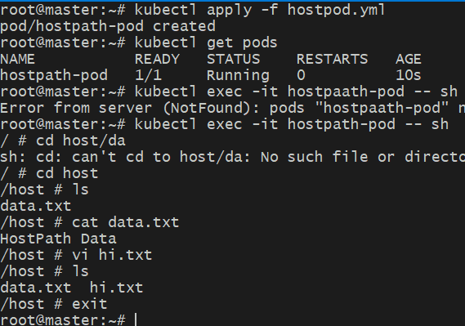
Delete & Recreate Pod
# kubectl delete pod hostpath-pod
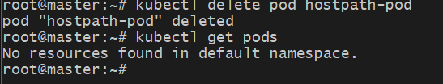
# kubectl apply -f hostpath-pod.yaml
Verify Persistence
# kubectl exec -it hostpath-pod -- cat /host/data.txt
You can see the data in the hostpath is still present after the delete and recreation of the pod
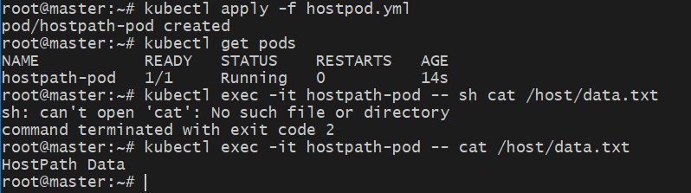

3.Deploy an Amazon EBS Volume Using Persistent Volume and Persistent Volume Claim (PVC)
Create one EBS volume
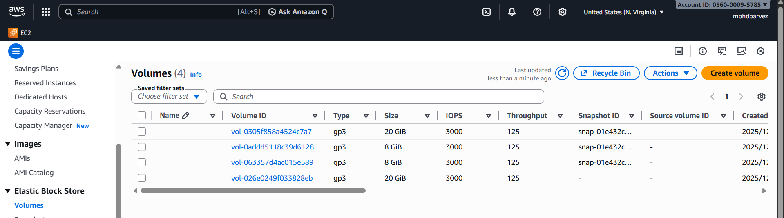
Create one IAM role for aws-ebs-csi-driver
Search for = AmazonEBSCSIDriverPolicy and create one role and attach to all the nodes in k8s cluster.
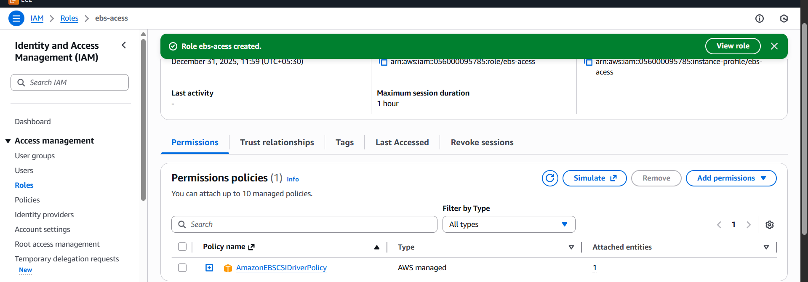
Attach role to the instances
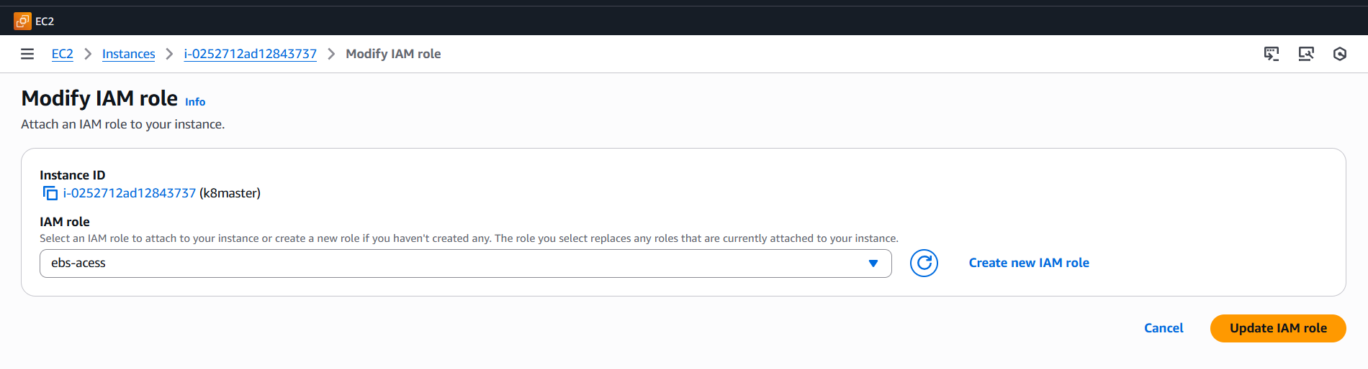
3)Install AWS EBS CSI driver on k8s master node.
#) git clone https://github.com/kubernetes-sigs/aws-ebs-csi-driver.git
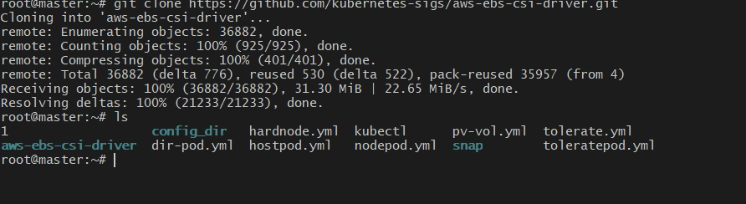
#) cd aws-ebs-csi-driver
#) kubectl apply -k deploy/kubernetes/overlays/stable/
#) kubectl get pods -n kube-system #To verify the driver is installed and running.
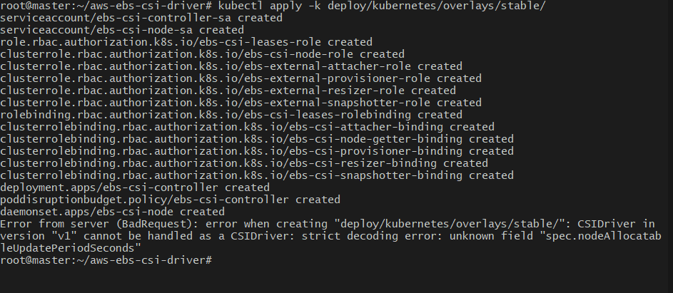
4) Now we need to create one Persistent volume for our EBS.
# vi pv-vol.yml
apiVersion: v1
kind: PersistentVolume
metadata:
name: ebs-pv
spec:
capacity:
storage: 5Gi
volumeMode: Filesystem
accessModes:
- ReadWriteOnce
awsElasticBlockStore:
storageClassName: aws-ebs
volumeID: vol-026e0249f033828eb
fsType: ext4
persistentVolumeReclaimPolicy: Retain
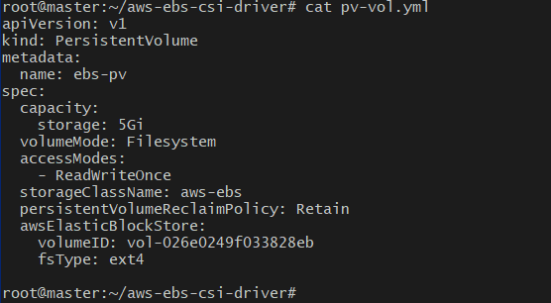
# kubectl apply -f pv-vol.yml
# kubectl get pv
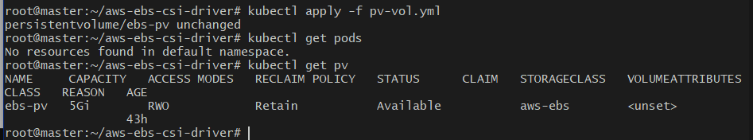
Create Persistent Volume Claim (PVC)
# vi ebs-pvc.yml
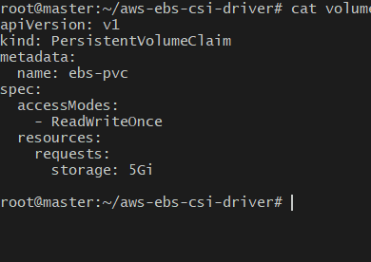
apiVersion: v1
kind: PersistentVolumeClaim
metadata:
name: ebs-pvc
spec:
accessModes:
- ReadWriteOnce
resources:
requests:
storage: 5Gi

# kubectl apply -f ebs-pvc.yml
#kubectl get pvc
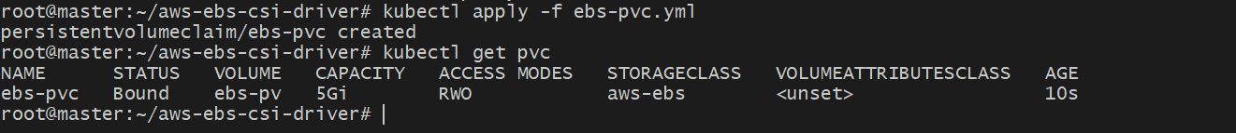
Create Pod Using PVC
# vi pvcpod.yml
apiVersion: v1
kind: Pod
metadata:
name: ebs-pod
spec:
containers:
- name: app
image: busybox
command: ["sh", "-c", "echo EBS Data > /data/ebs.txt && sleep 3600"]
volumeMounts:
- mountPath: /data
name: ebs-volume
volumes:
- name: ebs-volume
persistentVolumeClaim:
claimName: ebs-pvc
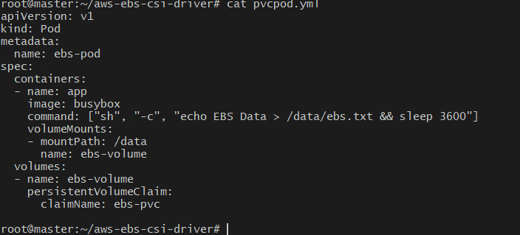

Verify Persistence
# kubectl get pods
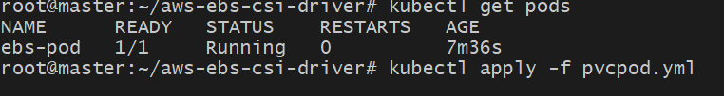

# kubectl exec -it ebs-pod -- cat /data/ebs.txt

4.Set Up an Amazon EFS Volume and Attach it to Multiple Pods
Create EFS File System (AWS Console)
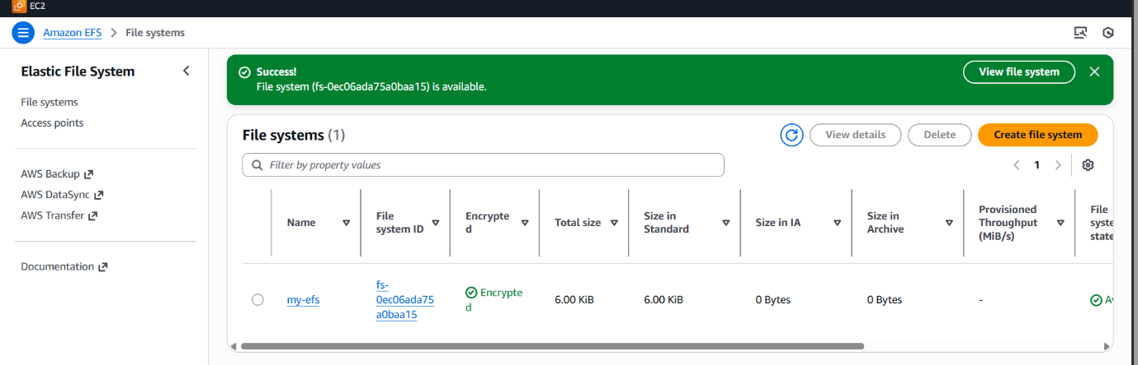
Create an acess point
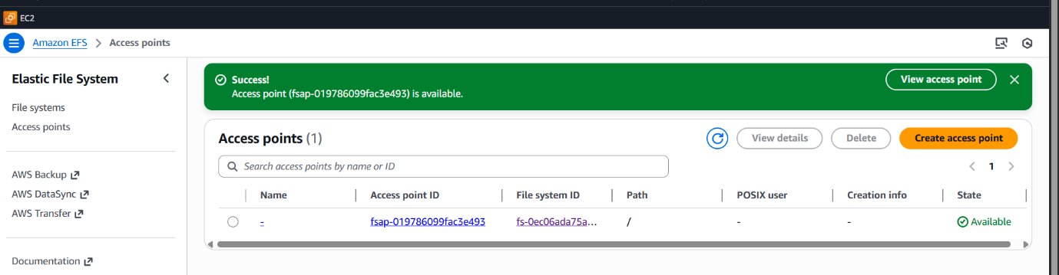
Install AWS EFS CSI driver on k8s master node.
git clone https://github.com/kubernetes-sigs/aws-efs-csi-driver.git


cd aws-efs-csi-driver/deploy/kubernetes/overlays/stable/
kubectl get pods -n kube-system -l app=efs-csi-controller
kubectl get pods -n kube-system -l app=efs-csi-node

storageclass.yaml
apiVersion: storage.k8s.io/v1
kind: StorageClass
metadata:
name: efs-sc
provisioner: efs.csi.aws.com

# kubectl apply -f storageclass.yaml #To create storage class
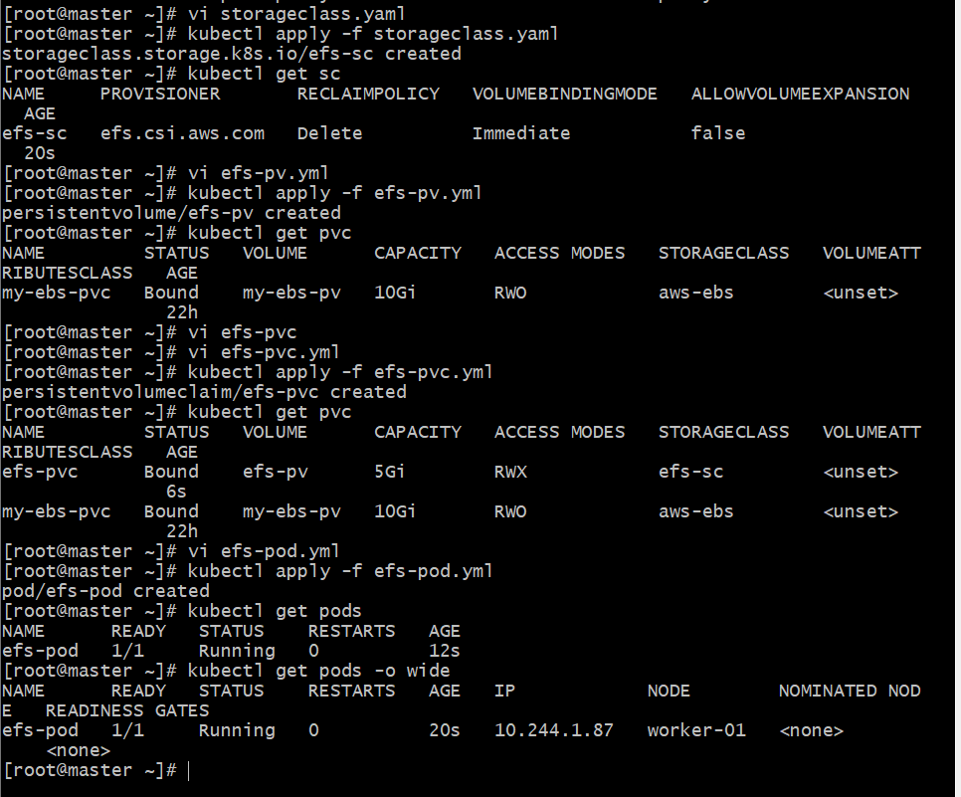

Now we need to create one Persistent volume for our EFS.

#vi pv-vol.yml
apiVersion: v1
kind: PersistentVolume
metadata:
name: efs-pv
spec:
capacity:
storage: 5Gi
accessModes:
- ReadWriteMany
persistentVolumeReclaimPolicy: Retain
storageClassName: efs-sc
csi:
driver: efs.csi.aws.com
volumeHandle: <efs-file-system-id>::<efs-access-point-id>


kubectl apply -f pvc.yaml


# vi pvc.yml
apiVersion: v1
kind: PersistentVolumeClaim
metadata:
name: efs-pvc
spec:
accessModes:
- ReadWriteMany
storageClassName: efs-sc
resources:
requests:
storage: 5Gi

# kubectl apply -f pvc.yaml
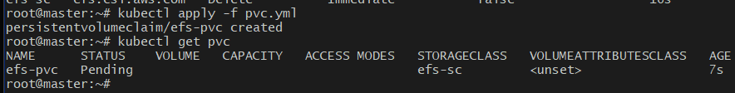
Create pod with PVC.
# vi efs-pod.yml
apiVersion: v1
kind: Pod
metadata:
name: efs-pod
spec:
containers:
- name: my-app
image: nginx
volumeMounts:
- name: efs-volume
mountPath: /efs-mount
volumes:
- name: efs-volume
persistentVolumeClaim:
claimName: efs-pvc

kubectl apply -f efs-pod.yaml #To create pod with pv
●
How to test:
Create one pod and login to pod and create some random files in efs-mount directory.
Create one more pod and check if the files are available or not
Note:
Here we can map multiple pods to same EFS volume.
We can now connect multiple pods to same volume.
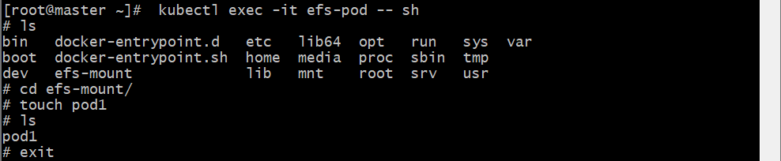
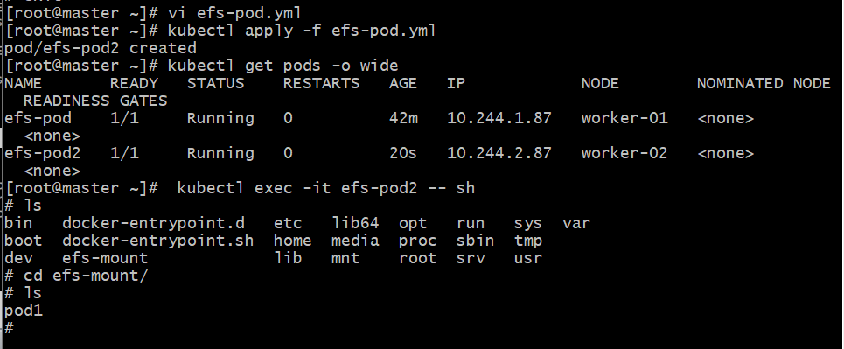


5.Implement and Test Liveness and Readiness Probes in a Kubernetes Pod

Create Pod with Probes
# vi prob-pod.yml
apiVersion: v1
kind: Pod
metadata:
name: probe-pod
spec:
containers:
- name: app
image: nginx
livenessProbe:
httpGet:
path: /
port: 80
initialDelaySeconds: 15
periodSeconds: 10
readinessProbe:
httpGet:
path: /
port: 80
initialDelaySeconds: 5
periodSeconds: 5
Deploy Pod
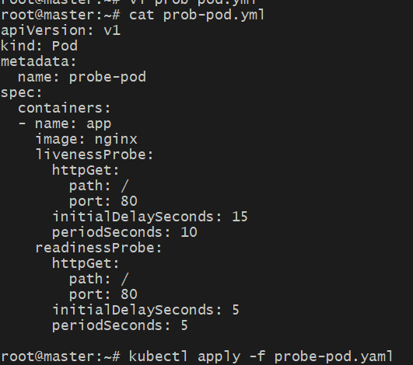
# kubectl apply -f prob-pod.yml
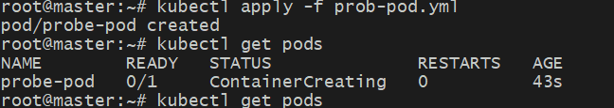
Monitor Probes
# kubectl describe pod probe-pod
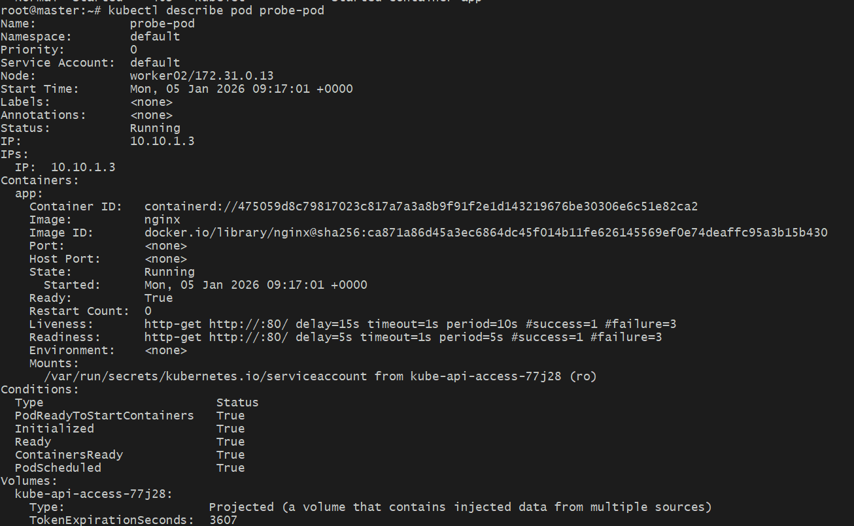

Test Liveness Failure
# kubectl exec -it probe-pod -- /bin/bash
rm /usr/share/nginx/html/index.html
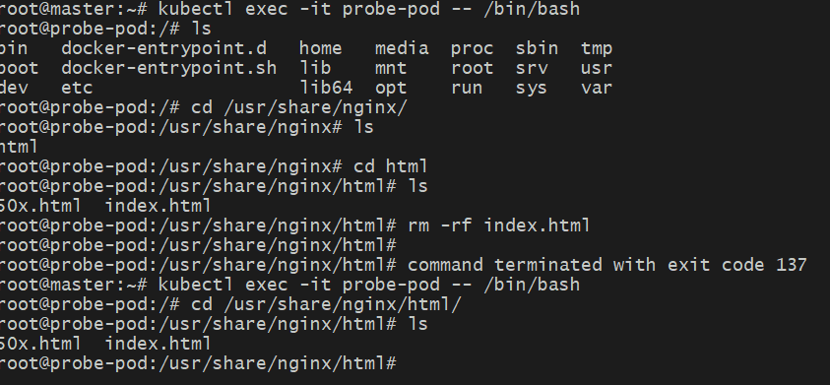
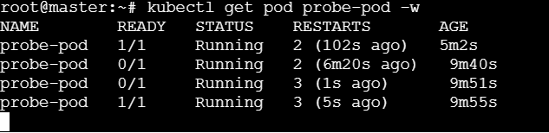
Pod will restart automatically

